Debugging

**Bug1** : Player winnings weren’t getting increased on the same dice value. To achieve this we now return unique value of the dice rolled. By checking if the list contains the value.

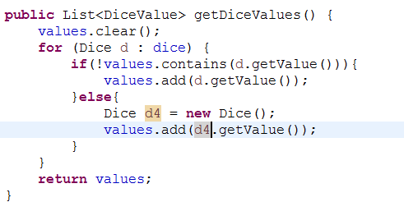

**Bug 2, Player is unable to quit the game.**

The code line below isn’t able to get the player input. It was subsequently replaced by Scanner API.



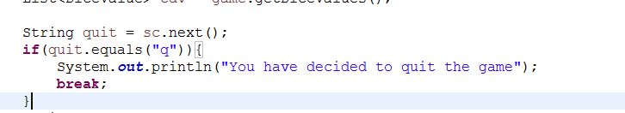

Once the player decides to quit i.e. press “q”, the game stops as the loop breaks.

**Bug 3**: The user name and the initial amount value was constant.

This can be seen below as the value Fred and 100 are hardcoded.

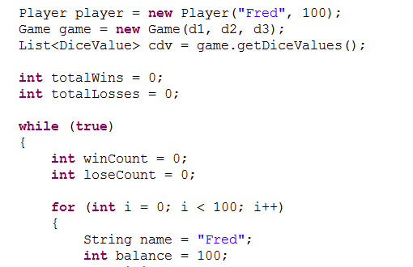

To fix this, Scanner API was used to get the input from the user:

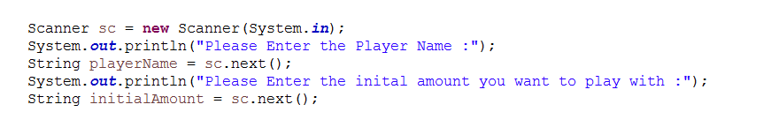

And subsequently used in initiating the class values.

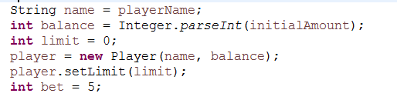

**Bug:** Player Cannot reach the limit value

The check within the Player.java for balance exceeds was wrong, modifying that condition solved the problem.

**Bug 0:** Game does not pay out at correct level. When player wins on 1 match, balance does not increase.



This method is removed for the first call by using below:

